

**"SOHO Gigabit Network Switch"**

**Internship report**

Submitted in partial fulfillment for the award of the degree of

**Bachelor of Technology**

**In**

**DEPARTMENT OF ELECTRONICS AND COMMUNICATION ENGINEERING (AI & CYBERNETICS)**

Submitted to

**VIT BHOPAL UNIVERSITY (M. P.)**

**Submitted by**

**KRITIKA TRIPATHI – 21BAC10032**

Under the Supervision of

**MAYANK KUMAR SINGH**

VELANKANI ELECTRONICS & AUTOMOTIVE PVT LTD, BENGALURU

**SCHOOL OF ELECTRICAL & ELECTRONICS ENGINEERING**

**VIT BHOPAL UNIVERSITY**

**BHOPAL (M.P.)-466114**

**December – 2024**

© VIT Bhopal University – 2024-2025



**VIT BHOPAL UNIVERSITY, Bhopal**

SCHOOL OF ELECTRICAL & ELECTRONICS ENGINEERING

**DECLARATION**

I hereby declare that the Dissertation entitled “SOHO Gigabit Network Switch” is my own work conducted under the supervision of Mayank Kumar Singh, Lead Hardware Design Engineer, Velankani Electronics & Automotive Pvt Ltd, Bengaluru.

I further declare that to the best of my knowledge this report does not contain any part of work that has been submitted for the award of any degree either in this university or in other university / Deemed University without proper citation.

Kritika Tripathi(21BAC10032)

This is to certify that the above statement made by the candidate is correct to the best of my knowledge.

Date: 17 Dec 2024

Mayank Kumar Singh

Lead Hardware Design Engineer



--------------------------------------------------------

Digital Signature of Guide



**VIT BHOPAL UNIVERSITY, Bhopal**

SCHOOL OF ELECTRICAL & ELECTRONICS ENGINEERING

**CERTIFICATE**

This is to certify that the work embodied in this Capstone project report entitled **“SOHO GIGABIT NETWORK SWITCH”** has been satisfactorily completed by **Ms. KRITIKA TRIPATHI (21BAC10032)** in the School of Electrical & Electronics Engineering at VIT Bhopal University, Bhopal. This work is a Bonafide piece of work, carried out under my/our guidance in the Velankani Electronics & Automotive Pvt Ltd, Bengaluru for the partial fulfilment of the degree of Bachelor of Technology.



**PROJECT GUIDE**

|  |  |
| --- | --- |
|  | Mayank Kumar Singh |
|  | Lead Hardware Design Engineer |
|  |  |
|  |  |
| Forwarded by | Approved by |
|  |  |
| Dr. Soumitra K. Nayak | Dr. M Suresh |
| Program Chair,  B-Tech ECE (AI & Cybernetics)  School of Electrical and Electronics Engineering (SEEE) | Associate Professor & Dean  School of Electrical and Electronics Engineering (SEEE) |

**Acknowledgement**

I would like to express my sincere gratitude to **Velankani Electronics Automotive Pvt Ltd** for giving me the opportunity to complete my internship in PCB hardware design.

I extend my heartfelt thanks to my supervisor **Mayank Kumar Singh** for their guidance and support throughout the project. Their mentorship has been invaluable in helping me understand and implement the SOHO Gigabit Network Switch.

I would like to extend my gratitude to **Dr. Soumitra K. Nayak** for his supervision and guidance during my academic journey, whose inspiration and mentorship have always encouraged me to aim higher and excel.

Additionally, I am deeply grateful to **Dr. M. Suresh**, Associate Professor & Dean, School of Electrical and Electronics Engineering, VIT Bhopal University, for providing continuous support and the resources necessary for my technical growth.

Kritika Tripathi

21BAC10032

**Abstract**

The rapid evolution of networking technologies has created a growing demand for reliable, efficient, and cost-effective solutions for Small Office/Home Office (SOHO) environments. This project focuses on the design, development, and testing of 5-port and 8-port Gigabit Ethernet (GE) SOHO switches, engineered to meet the requirements of high-speed, seamless connectivity in compact setups. These unmanaged switches are designed to support plug-and-play functionality, enabling effortless network expansion without requiring any complex configurations.

The project entailed multiple phases of development, starting with the design of printed circuit board (PCB) schematics and selection of essential components based on cost, availability, and performance criteria. A meticulous Bill of Materials (BOM) was prepared, ensuring the inclusion of high-quality components while optimizing production costs. Prototype development followed, incorporating innovative designs that feature a fanless architecture for silent operation and energy-efficient technologies to minimize power consumption.

The testing phase was comprehensive, covering hardware validation to ensure physical and functional integrity, port connectivity analysis to verify seamless communication between devices, throughput performance evaluation to confirm adherence to Gigabit Ethernet standards, and energy efficiency assessments to benchmark power-saving capabilities. These tests ensured that the switches operate reliably under varying network conditions while maintaining optimal performance.

The final deliverables of the project include robust, user-friendly networking switches tailored for SOHO environments. Their compact design, silent operation, and energy efficiency make them ideal for applications in small businesses, home offices, and other similar setups. These devices enhance network reliability and performance, contributing significantly to the expanding portfolio of SOHO networking products.

**List of Figures**

|  |  |  |
| --- | --- | --- |
| Figure No. | Caption / Title | Page No. |
| 1.1  1.2  1.3  1.4  1.5  1.6  1.7  1.8  1.9  2.0  2.1  2.2  2.3 | SOHO Network Switch  5 – Port 1000Base – T Switch  8 – Port 1000Base – T Switch  Buck Converter Circuit  SOHO Switch 5 – Port  SOHO Switch 8 – Port  Flow Chart  SOHO Switch 5 – Port Top & Bottom View  SOHO Switch 8 – Port Top & Bottom View  Pannel Drawing for SOHO 5GE & 8GE  Assembled PCB for SOHO 5GE  Assembled PCB for SOHO 5GE  Working of SOHO Switch | 1  7  8  9  11  12  15  17  18  19  20  21  23 |

**List of Symbols & Abbreviations**

**SOHO Small Office/Home Office**

**GE Gigabit Ethernet**

**PCB Printed Circuit Board**

**BOM Bill of Materials**

**LAN Local Area Network**

**RJ45 Registered Jack 45 (Ethernet Port)**

**LED Light-Emitting Diode**

**Gbps Gigabits per Second**

**PoE Power over Ethernet**

**V Voltage**

**A Ampere**

**MAC Media Access Control**

**IC Integrated Circuit**

**SMT Surface-Mount Techno logy**

**RoHS Restriction of Hazardous Substances**

**EMI Electromagnetic Interference**

**ESD Electrostatic Discharge**

**QoS Quality of Service**

**IEEE Institute of Electrical and Electronics Engineers**

**TCP/IP Transmission Control Protocol/Internet Protocol**

**EEPROM Electrically Erasable Programmable Read-Only Memory**

**DRAM Dynamic Random Access Memory**

**SMPS Switched-Mode Power Supply**

**Table of Contents**

|  |  |  |
| --- | --- | --- |
|  | Contents | Page no. |
|  | Front page | I |
|  | Candidate’s Declaration | II |
|  | Certificate | III |
|  | Acknowledgement | IV |
|  | Abstract | V |
|  | List of Figures | VI |
|  | List of Symbols & Abbreviations | VII |
|  | Table of Contents | VIII |
| Chapter 1 | Introduction | 01 |
|  | Motivation of the study | 02 |
|  | Objective of the work | 02 |
| Chapter 2 | Literature review | 04 |
| Chapter 3 | Problem Formulation and proposed methodology | 06 |
|  | 3.1 Problem formulation | 06 |
|  | 3.2 Proposed methodology | 06 |
|  | 3.2.1 Components | 08 |
|  | 3.3 Implementation | 12 |
|  |  |  |
| Chapter 4 | Results and Discussion | 23 |
| Chapter 5 | Conclusion | 24 |
| References |  | 25 |
| Appendices |  | 26 |

**Chapter 1**

**1.1 Introduction**

Ethernet switches play a pivotal role in modern networking systems by connecting multiple devices in a local area network (LAN) and facilitating seamless data transmission. As data demands grow, the need for high-performance, scalable, and energy-efficient switches becomes crucial, especially in environments requiring high-speed connectivity. This project focuses on designing and implementing Ethernet switches based on the RTL8367N-VB-CG (5-port) and RTL8367N-VB (8-port) ICs from Realtek. These chips integrate high-speed Gigabit Ethernet switching with PHYs, supporting advanced features like VLAN, QoS, and traffic management. The RTL8367N-VB-CG and RTL8367N-VB are designed to address the needs of small office and home office (SOHO) networks as well as larger setups requiring scalable solutions. This report provides a detailed overview of the design considerations, PCB design, testing, and performance evaluation of the two versions of the Ethernet switch. The RTL8367N series provides a robust and flexible platform to meet the demands for high-speed data transmission, efficient network management, and energy-efficient operation.

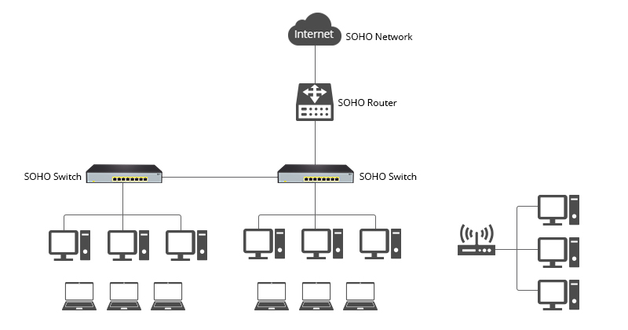

**Fig 1.1 SOHO Network Switch**

**1.2 Motivation**

The rapid advancement of digital technologies, such as the proliferation of IoT devices, high-definition streaming, and cloud computing, has resulted in an increasing need for fast, reliable, and secure networking infrastructure. As network speeds and device counts grow, the traditional networking solutions face limitations in scalability, speed, and efficiency. This presents a significant challenge for businesses and homes, necessitating the development of more sophisticated Ethernet switches that can handle higher throughput, provide more ports, and offer features such as Quality of Service (QoS), VLAN management, and energy efficiency. The motivation behind this project stems from the necessity to develop high-performance Ethernet switches that can support the growing demands of modern networks. The RTL8367N-VB-CG (5-port) and RTL8367N-VB (8-port) switches are designed to meet these requirements, offering compact, integrated solutions for both small and larger-scale networks. The use of advanced technologies like Gigabit Ethernet, Jumbo Frames, and secure VLAN configurations makes these designs suitable for contemporary networking environments. The motivation is to build on these advancements and create robust, scalable switch designs that can handle the evolving requirements of data transmission, security, and efficiency.

**1.3 Objective of the work**

The primary objective of this project is to design, implement, and optimize a 5-Port and 8-Port SOHO (Small Office/Home Office) Gigabit Unmanaged Ethernet Switch, which will provide reliable and high-performance network connectivity for small-scale networking environments. The goal is to create a cost-effective, energy-efficient, and easy-to-use networking device for homes and small offices. Key objectives for this project include:

* **Design and Implementation of High-Performance Switch**: Develop a fully functional 5-port and 8-port unmanaged Ethernet switch that supports Gigabit (10/100/1000Mbps) speeds for high-speed data transmission.
* **Non-Blocking Switch Architecture**: Ensure data can be transmitted simultaneously between any pair of ports without interference, improving overall network throughput.
* **Integration of RTL8367N-VB Gigabit Ethernet Switch IC**: Utilize the RTL8367N-VB-CG Ethernet switch controller to handle packet forwarding, MAC learning, and switching functions.
* **Power Efficiency and Low Latency**: Integrate energy-efficient components with automatic power-saving features, ensuring the switch operates efficiently with minimal heat generation.
* **VLAN and Traffic Management**: Implement VLAN support and traffic management features (prioritization, bandwidth control, and flow control) to optimize network performance.
* **Easy Plug-and-Play Setup**: Design the switch to be plug-and-play with minimal configuration, enabling users to easily install and use the switch in SOHO environments.
* **Robust Security Features**: Include built-in security features like 802.1x access control, port isolation, and storm control to enhance network security.
* **Compact and Cost-Effective Design**: Develop the switch in a small, durable, and cost-effective form factor, balancing performance and affordability.
* **Testing and Validation**: Conduct extensive testing to validate functionality, performance, and reliability, including network throughput, packet loss, latency, and stress testing.

**Chapter 2**

**2.1 Literature Review**

**[1] Janche Sang (2010): *Hands-on laboratory experiments with SOHO networking technologies***. This paper presents several laboratory experiments aimed at providing hands-on experience with small office/home office (SOHO) networking technologies, such as SOHO Router/Firewall, Wi-Fi Wireless LAN, HomePlug Powerline Communication, and HomePNA Phoneline Networking. The study emphasizes the benefits of practical exposure to these networking technologies for improving students' understanding and application of theoretical networking concepts. Feedback from students indicates that these hands-on projects positively impacted their learning and comprehension of networking systems. The research underlines the importance of practical experiments in network education and their role in bridging the gap between theoretical knowledge and real-world applications.

**[2] S.K. Tso, B.L. Luk, W.H. Choy, K.P. Liu, C.S. Chow, K.F. Leung (2003): *An Intelligent Networking and Automation System for Home and SOHO Environments.*** This study discusses the development of an intelligent networking and automation system for SOHO environments, designed to handle heterogeneous network systems. The system uses open standards like OSGi (Open Service Gateway Initiative) and UPnP (Universal Plug and Play) for seamless integration and easy device management. It integrates various communication technologies, including Bluetooth, RF, and broadband Internet, to create a flexible network that can easily adapt to changing device configurations. The research highlights the challenges of managing diverse technologies in SOHO systems and provides insights into the development of commercial products and experimental platforms for SOHO automation.

**Chapter 3**

**3.1 Problem formulation**

With the increase in network traffic in small office/home office environments, there is a demand for efficient and reliable unmanaged switches that are easy to install and operate. The challenge lies in designing hardware that optimizes power consumption, ensures reliability, and operates seamlessly for multiple connected devices.

The key challenges are:

* **Efficient Power Delivery**: Reducing energy consumption while maintaining performance.
* **Cost Optimization**: Developing a cost-effective design without compromising quality.
* **Reliability**: Ensuring consistent and robust connectivity in real-world conditions.

**3.2 Proposed methodology**

The system design focuses on the following methodology:

1. **Component Selection**:
   * Components like low-power ICs, capacitors, connectors, and inductors are carefully chosen to meet power and cost constraints.
   * The **TLV62569 Buck Converter** ensures efficient power conversion from 5V to required levels like 3.3V and 1.1V, maintaining overall efficiency.
   * Other components like Ethernet controllers, resistors, and connectors are chosen for minimal power loss and maximum compatibility.
2. **Schematic Design**:
   * The hardware schematic design involves interconnecting selected components, ensuring proper power supply rails, grounding, and signal flow.
   * **Simulation tools** are used to verify the schematic before PCB layout.
3. **PCB Layout**:
   * The PCB layout focuses on a multi-layer design to minimize impedance, avoid crosstalk, and optimize power distribution.
   * Signal integrity techniques are applied to ensure high-speed performance with minimal EMI/EMC interference.
   * Proper placement of components helps in thermal management and overall reliability.

**Steps involved in PCB Design:**

* + **Schematic Capture**: Importing the schematic into the PCB design software.
  + **Stack-Up Planning**: Defining the number of layers for power, ground, and signals.
  + **Component Placement**: Positioning components to optimize routing and heat dissipation.
  + **Routing**: Connecting components with tracks ensuring minimal resistance and maximum signal quality.
  + **Design Rule Checks (DRC)**: Verifying track widths, spacing, and overall integrity of the design.

1. **Prototype Development**:
   * Fabricating the PCB based on the design specifications.
   * Assembling the components onto the board for prototyping.
2. **Testing and Validation**:
   * **Bare Board Testing**: Checking for open circuits, short circuits, and connectivity.
   * **Functional Testing**: Powering the PCB and verifying voltage levels.
   * **Signal Integrity Test**: Ensuring minimal noise and EMI on critical signal paths.
   * **Thermal Testing**: Measuring heat dissipation and component temperature.
   * **Power Consumption Measurement**: Measuring current and power consumption under load.

The proposed methodology ensures that the design meets performance, reliability, and cost requirements.

**3.2.1 Components**

**I. RTL8367N IC (Used for 5-Port Switch):**

The RTL8367N is a highly integrated, advanced Ethernet switch IC designed for consumer applications like SOHO (Small Office/Home Office) gigabit switches. This IC supports five Ethernet ports, including one for a high-speed uplink and four for local devices. It features a rich set of functions such as QoS (Quality of Service), VLAN (Virtual Local Area Network), and security features like port-based security and MAC address filtering, ensuring optimized performance and network security. The RTL8367N also integrates a robust power management system to reduce power consumption, which is crucial for maintaining the energy efficiency of networking devices. Additionally, it supports IEEE 802.1p and 802.1Q standards for VLAN and priority tagging, making it highly compatible for a wide range of Ethernet applications. Its compact form factor and power-efficient design make it ideal for use in networking products like switches, routers, and hubs.

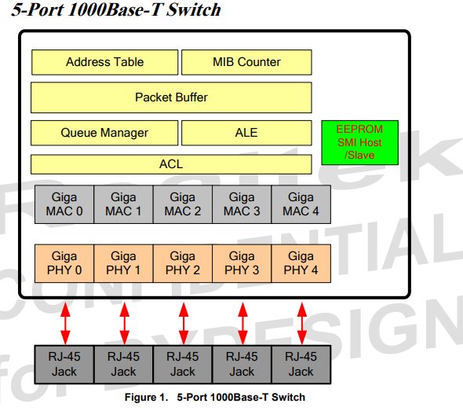

**Fig 1.2 5 – Port 1000Base – T Switch**

**II. RTL8370N IC (Used for 8-Port Switch):**

The RTL8370N is a versatile and high-performance Ethernet switch IC designed for use in SOHO gigabit network switches, offering eight Ethernet ports. Like its counterpart, the RTL8367N, the RTL8370N supports essential features such as VLAN tagging, QoS management, and port security. It is ideal for larger networks requiring more ports, providing excellent performance while maintaining low power consumption. This IC is also designed to work with various PHY chips, allowing it to support 10/100/1000 Mbps Ethernet speeds for both uplink and downlink traffic. The RTL8370N supports a wide range of power management features, including automatic power-down modes for unused ports, helping extend the overall battery life of the device. This IC's architecture ensures high throughput and reliability, making it suitable for more demanding applications requiring greater port density.

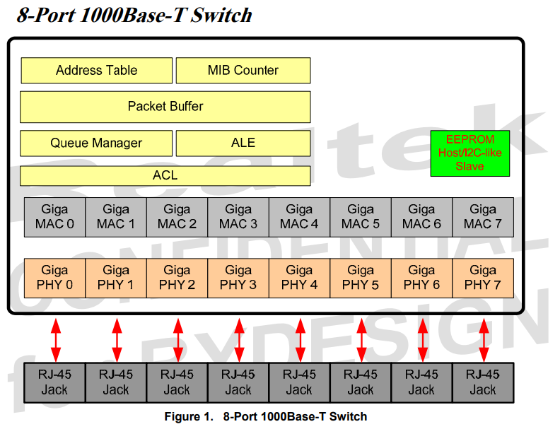

**Fig 1.3 8 – Port 1000Base – T Switch**

**III . TLV62569 Step-Down Buck Converter IC:**

The TLV62569 is a highly efficient synchronous buck converter IC used to step down voltages in a variety of applications. In this project, it is utilized to convert 5V to both 3.3V and 1.1V, which are required for different components within the 5-port and 8-port SOHO gigabit network switches. The IC operates with a high efficiency of up to 96%, reducing energy losses and heat generation, which is critical in maintaining the stability and longevity of the device. It features an integrated power MOSFET, low quiescent current, and a wide input voltage range, making it a suitable choice for both battery-powered and externally powered devices. Its small form factor and ease of integration help save PCB space and reduce component count, making it an ideal choice for compact electronic designs like networking hardware.

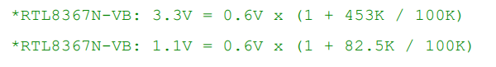

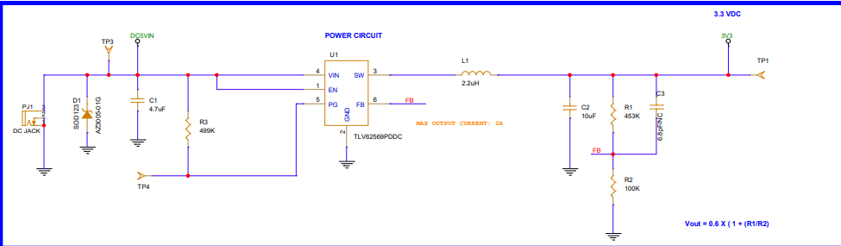

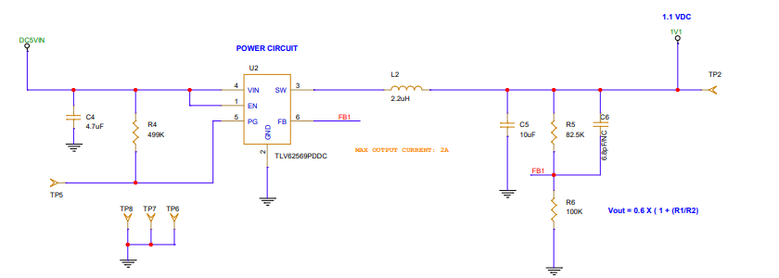

**Fig 1.4 Buck Converter Circuit**

**IV. RJ45 Connector:**

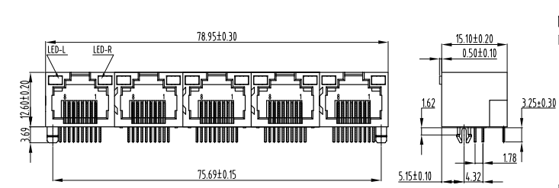

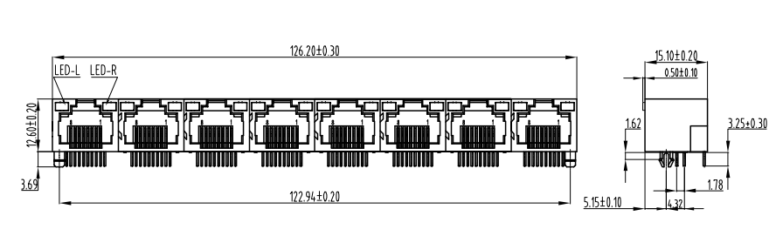

**V.** **Dual Port Plus Transformers:**

The HS2409S is a high-performance dual-port transformer used in Ethernet applications to provide isolation between the network switch and the attached devices, such as computers or other switches. These transformers are essential for preventing electrical noise from traveling between the two sides of the connection, ensuring signal integrity. The dual-port design of the HS2409S makes it ideal for switches with multiple Ethernet ports, as it supports bidirectional communication across each port while maintaining high-quality signal transmission. The transformer is designed to operate efficiently at both high and low frequencies, providing excellent impedance matching and reducing signal reflections, which is crucial for maintaining data integrity in high-speed Ethernet communication.

**VI. 25MHz Crystal:**

he 25MHz crystal oscillator is used in the network switch for clock generation, ensuring precise timing for the ICs, communication protocols, and data transfer processes. The accuracy and stability of the crystal oscillator are critical in high-speed networking applications where synchronization is essential. The 25MHz frequency is commonly used in Ethernet communication devices, as it is the frequency required for accurate data transmission and reception. This component provides the timing signals for various circuits, enabling the network switch to maintain reliable and efficient data flow.

**VII. EPROM (Erasable Programmable Read-Only Memory):**

EPROM (Erasable Programmable Read-Only Memory) is used in networking devices for storing firmware or configuration data. It allows for data to be written and erased multiple times using ultraviolet light, providing a reliable and non-volatile memory solution. In this network switch, the EPROM stores the device's firmware, which is essential for the initialization, configuration, and operation of the device. The EPROM allows for easy updates to the device's firmware, ensuring that the switch can support new features or fix any bugs in its operation. Its non-volatile nature means that data is retained even when the device is powered off.

**VIII. 5V AC-DC Adapter**

The external 5V AC-DC adapter is used to provide power to the network switch. This component converts alternating current (AC) from a standard electrical outlet into a regulated 5V direct current (DC), which is required by the switch's internal circuits. The adapter is designed to ensure that the network switch receives a stable and reliable power supply, regardless of fluctuations in the AC input. It plays a crucial role in powering the entire system, from the ICs to the peripheral components, ensuring proper operation of the device. This adapter is typically lightweight and compact, making it easy to integrate into a home or office environment.

**IX. DC Jack:**

The DC jack is a connector used to provide the network switch with a stable DC input from an external power source, such as the external 5V AC-DC adapter. It is used for easy connection and disconnection of the power supply, ensuring the switch can be powered off or replaced if necessary. The DC jack ensures that the device receives the correct polarity and voltage from the power source, which is vital for the protection and proper functioning of the internal circuits. It is designed for durability and reliability, typically made of high-quality materials to ensure a secure connection over extended use.

**3.3 Implementation**

**3.3.1 Block Diagram**

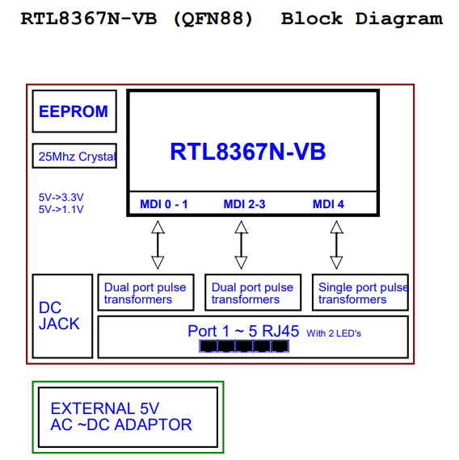

**Fig 1.5 SOHO Switch 5 – Port**

The **block diagram** serves as the conceptual layout of the system. It provides a high-level view of how different components are interconnected and helps in understanding the signal flow and power distribution. In this case, the main components are:

* **Ethernet Switch ICs**: RTL8367N (for the 5-port version) and RTL8370N (for the 8-port version) are the central ICs managing the Ethernet switch functionality.
* **Power Supply (Buck Converter IC TLV62569)**: This step-down converter regulates the voltage from 5V to 3.3V and 1.1V required for powering the ICs.
* **RJ45 Connectors**: These connectors provide the physical interface for Ethernet network connections.
* **Dual-port Transformers (HS2409S)**: Used to provide isolation and reduce noise in the data transmission lines.
* **25MHz Crystal Oscillator**: Supplies clock signals to the Ethernet switch ICs for reliable operation.
* **EPROM**: Stores the firmware necessary for switch configuration and operation.
* **External Power Source**: The 5V power is supplied through an external AC-DC adapter.

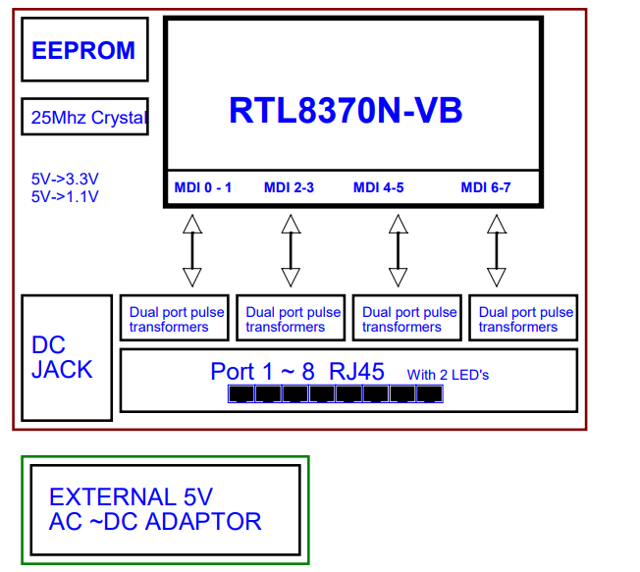

**Fig 1.6 SOHO Switch 8 – Port**

**3.3.2 Schematic Design**

The **schematic design** step involves placing and connecting all the components in the design. This stage ensures that all components are connected as per the requirements of the system. The following key connections are made:

* **Ethernet Switch ICs (RTL8367N and RTL8370N)**: These ICs are connected to the **RJ45 connectors** via **dual-port transformers** for proper signal integrity.
* **Step-down Buck Converter (TLV62569)**: This IC takes the 5V input power and converts it into 3.3V and 1.1V outputs required for the Ethernet switch ICs and other components.
* **Clock Signals**: The **25MHz crystal oscillator** is connected to the switch ICs to supply the clock signals needed for data transmission synchronization.
* **Power Supply Connections**: Power rails are routed from the buck converter to the appropriate components, ensuring proper voltage levels for the ICs.

<https://drive.google.com/file/d/1QtZj4Q00rkcZUTcwrI4RjA6xo0jQ3qPy/view?usp=sharing>

<https://drive.google.com/file/d/1QzfqJNYSQSRehwKQ5FapPPOCaGpqhRHC/view?usp=sharing>

**3.3.3 Flow Chart**

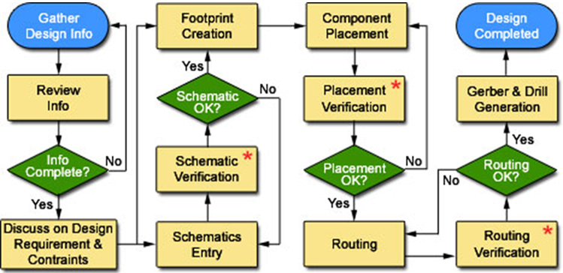

**Fig 1.7 Flow Chart**

**3.3.4 Design Rule Check & Netlist Creation**

The Design Rule Check (DRC) is performed to verify that the schematic design adheres to the manufacturing and electrical constraints. The DRC ensures that:

The components are placed with the correct clearances to avoid short circuits.

Traces have the correct width based on the current they will carry.

There is adequate clearance between traces and pads to ensure no unwanted shorting.

Power and ground traces are correctly routed, with sufficient width to handle the required current.

The **netlist** is a file that contains all the component connections. It is created after the schematic design is completed and is used to verify that the physical layout matches the logical schematic design. The netlist represents the electrical connectivity between the components in the form of a list, which is essential for routing and creating the PCB layout.

**3.3.5 PCB Layout Design**

The **PCB layout** design is one of the most crucial steps in ensuring the correct operation of the system. The components are placed on the PCB and connected via traces, with careful attention to high-speed signals and power integrity. The following considerations are made during this phase:

* **Component Placement**: Components are placed based on electrical and mechanical constraints, ensuring that the high-speed traces (Ethernet signals) are kept as short as possible to minimize signal loss.
* **Trace Routing**: The routing of electrical connections between components is carefully done, paying attention to impedance control for high-speed signals and minimizing noise.

Key aspects of the PCB layout design include:

* **Fab Notes**: These are additional instructions to the PCB manufacturer, such as special requirements for trace widths, hole sizes, and finish.
* **Stack-up**: The layer structure of the PCB is defined. For high-speed circuits like Ethernet, proper impedance control is crucial, and the stack-up ensures that traces maintain a controlled impedance.
* **PCB Thickness and Material**: The PCB material (usually FR4) and thickness are selected based on the electrical and thermal performance needed(1.2mm).

The layout design is reviewed to ensure compliance with manufacturing specifications and electrical performance standards.

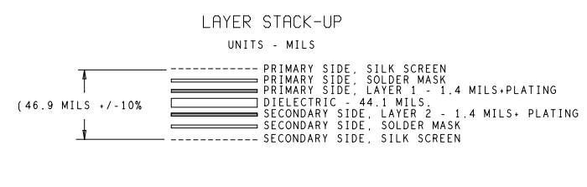

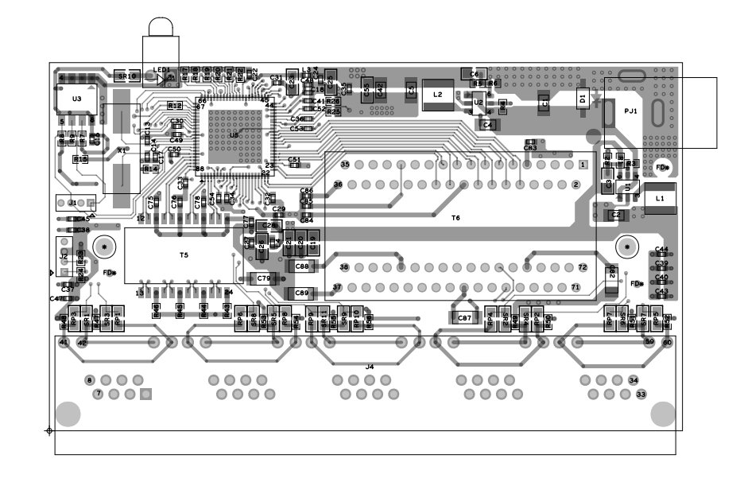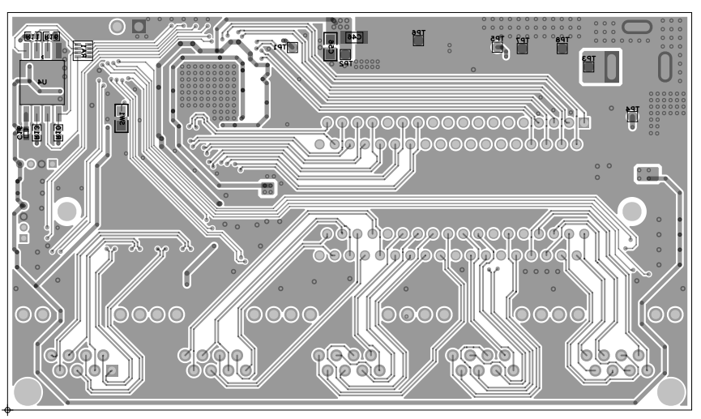

**Fig 1.8 SOHO Switch 5 – Port Top & Bottom View**

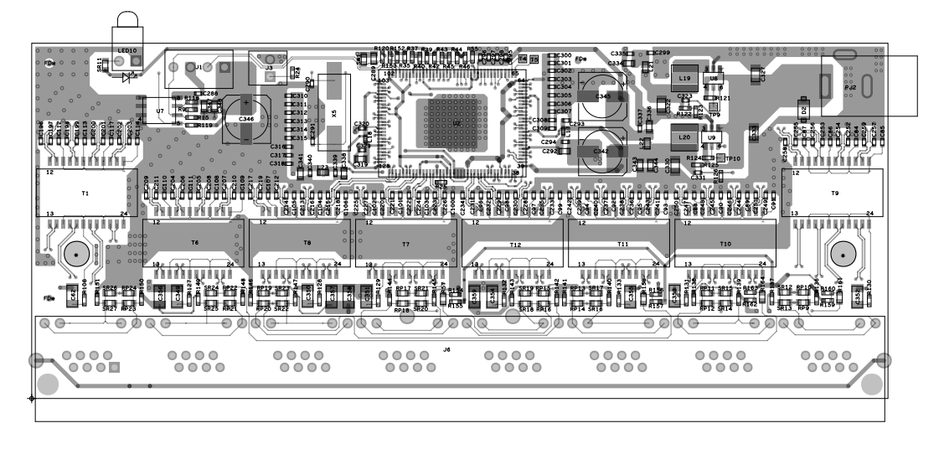

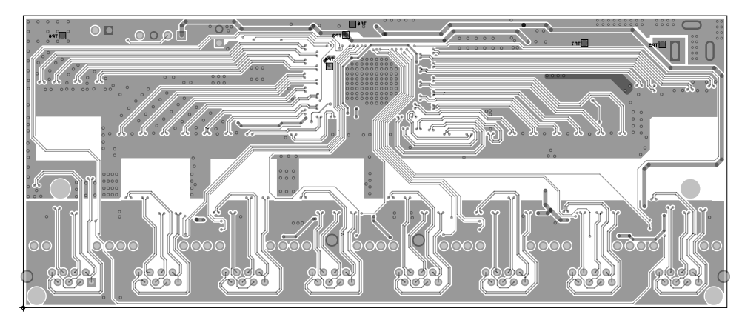

**Fig 1.9 SOHO Switch 8 – Port Top & Bottom View**

**3.3.6 Gerber File Generation**

After finalizing the PCB layout, Gerber files are generated. These files are the standard format used by PCB manufacturers to fabricate the PCB. The Gerber files contain the following information:

Copper Layers: The top and bottom layers for signal and ground traces.

Drill Files: Information on where holes are drilled for vias and component leads.

Solder Mask: The protective coating applied to the PCB to prevent short circuits.

Silkscreen Layers: The layer containing the component labels and other markings for assembly.

The Gerber files are essential for ensuring that the PCB is fabricated correctly.

**3.3.7 Panel Drawing and Panel Gerber Generation**

Panel drawing is created for the PCB if multiple boards are to be manufactured at once. The panel Gerber files represent multiple PCBs arranged on a single sheet for efficient manufacturing. The panelization allows for better utilization of the manufacturing process and is particularly useful when dealing with high-volume production

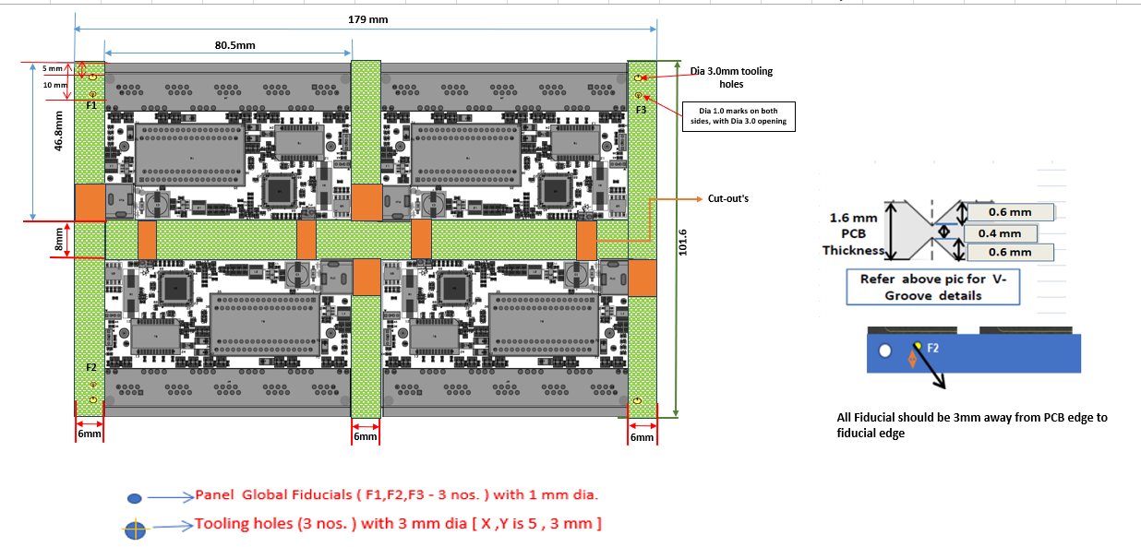

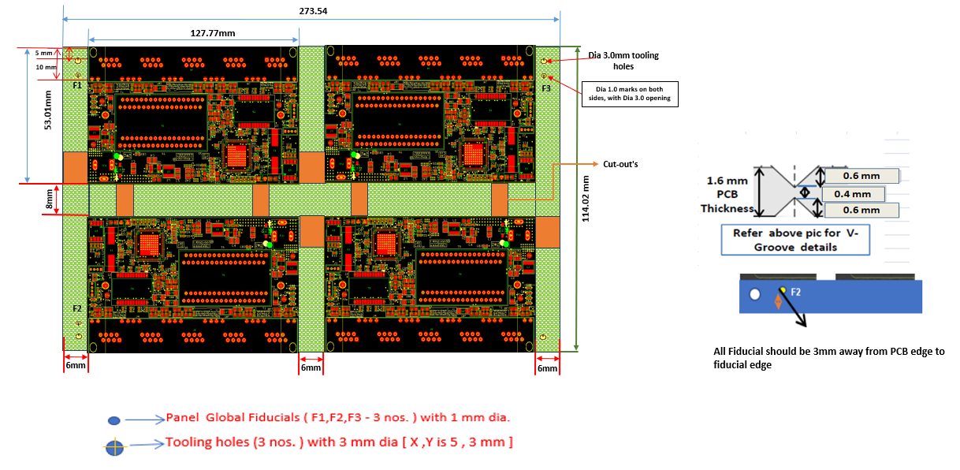

**Fig 2.0 Pannel Drawing for SOHO 5GE & 8GE**

**3.3.8 PCB Assembly**

Once the PCB is fabricated, PCB assembly takes place. This process involves placing the components on the PCB and soldering them into place. Automated pick-and-place machines are used to accurately place the components, and then a reflow soldering process is used to solder the components onto the PCB

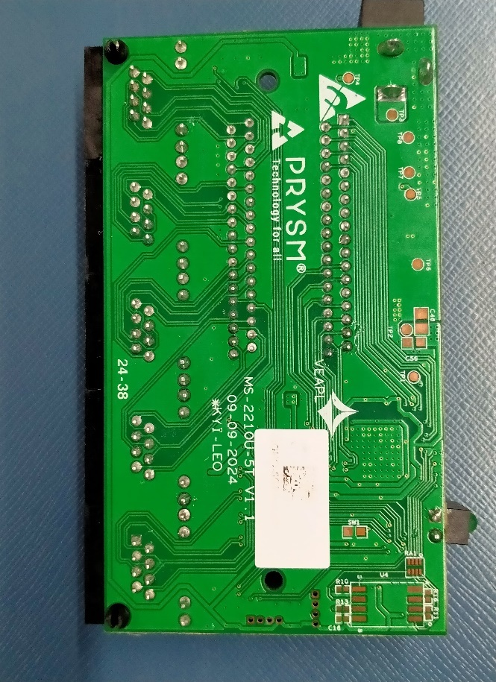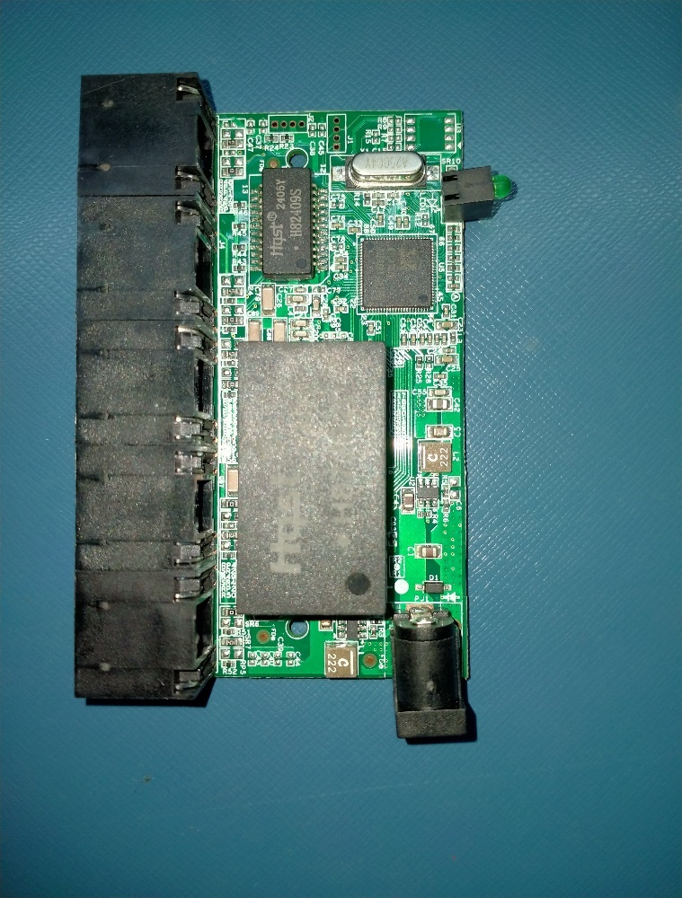

**Fig 2.1 Assembled PCB for SOHO 5GE**

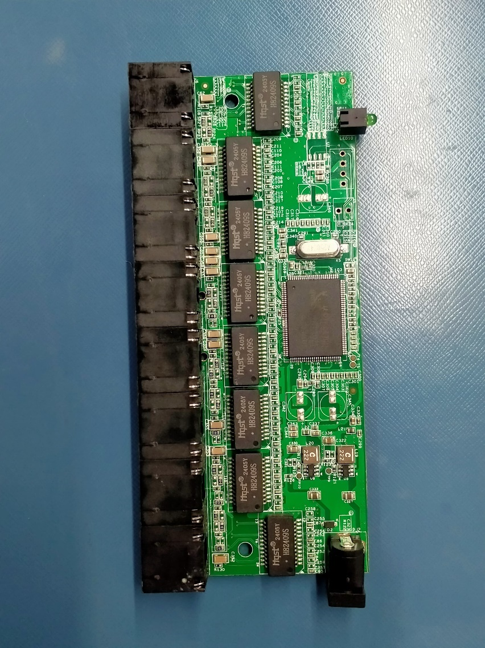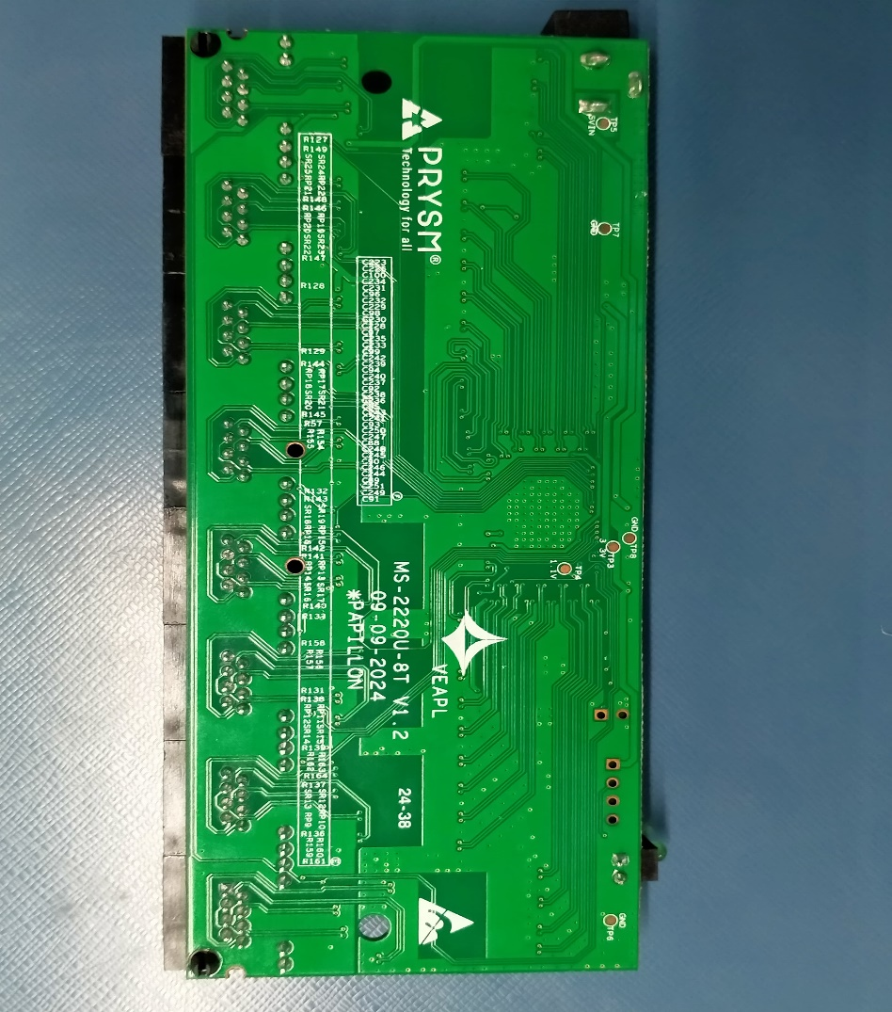

**Fig 2.2 Assembled PCB for SOHO 8GE**

**Chapter – 4**

**4.1 Results & Analysis**

**Voltage and Impedance Testing**After assembly, the **voltage and impedance tests** are conducted:

* **Voltage Testing**: The output voltages (3.3V and 1.1V) are verified using a multimeter or automated test equipment to ensure they meet the specifications required for the ICs and other components.
* **Impedance Testing**: High-speed signals require precise impedance control. The traces carrying Ethernet signals are tested to ensure they meet the desired impedance values to prevent signal degradation.

**Traffic Test:**  
Finally, a **traffic test** is performed to validate the functionality of the Ethernet switch. This test involves:

* Sending Ethernet data through the switch and verifying that packets are correctly forwarded between the ports.
* Testing the **VLAN functionality** and ensuring **QoS** (Quality of Service) features work as expected to manage traffic priorities.

If the traffic test passes, it confirms that the network switch is ready for use.

**Test Report:**

<https://docs.google.com/spreadsheets/d/1xRd_1Gmk-zbtyhYCjQmc_TfBcpLLY7M0/edit?usp=sharing&ouid=108682386440936554524&rtpof=true&sd=true>

<https://docs.google.com/spreadsheets/d/1gg3k-JMI9RGL6_rAfeMcUufrobHvsJsw/edit?usp=sharing&ouid=108682386440936554524&rtpof=true&sd=true>

**Chapter – 5**

**5.1 Conclusion**

The 5-port and 8-port SOHO Gigabit Network Switch project successfully demonstrates the design, implementation, and testing of a high-performance, reliable Ethernet switch tailored for small office/home office (SOHO) environments. By utilizing components such as the RTL8367N and RTL8370N Ethernet switch ICs, the TLV62569 step-down buck converter, RJ45 connectors, and dual-port transformers, the project ensures efficient data transfer, low latency, and power efficiency.

The systematic approach—from schematic design, DRC checks, and netlist creation to PCB layout, fabrication, and testing—ensures that the final product meets industry standards for performance, electrical integrity, and manufacturability. The switch was successfully tested for voltage levels, impedance matching, and Ethernet traffic, confirming its robustness and ability to handle high-speed networking requirements.

Overall, the project is a comprehensive solution for SOHO networking needs, offering reliable connectivity, power efficiency, and scalability, making it ideal for applications such as home offices, small businesses, and local area networks (LANs).

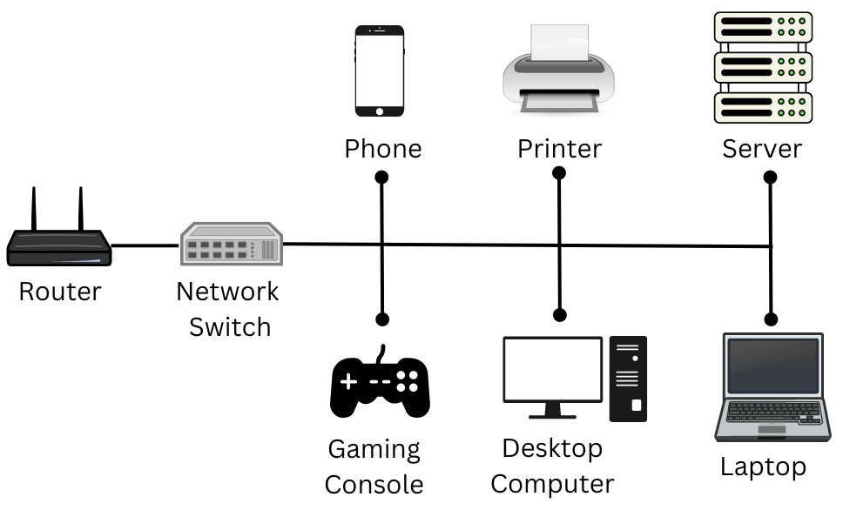

**Fig 2.3 Working of SOHO Switch**

**5.2 Future Stages**

While the current design provides a robust solution for basic networking needs in SOHO environments, there are several avenues for future enhancement:

1. **Advanced QoS Features**: Future versions of the switch could incorporate more advanced Quality of Service (QoS) features to optimize network performance for different types of traffic (e.g., voice, video, data), ensuring seamless operation in environments with diverse networking requirements.
2. **Support for Higher Speeds**: With the growing demand for faster internet speeds, the switch could be upgraded to support higher speeds, such as 10 Gigabit Ethernet, to cater to future networking demands in both residential and commercial sectors.
3. **Power-over-Ethernet (PoE)**: Integrating **Power over Ethernet (PoE)** functionality would allow the switch to power connected devices like IP cameras, VoIP phones, and Wi-Fi access points through the Ethernet cable, reducing the need for separate power supplies.

**References**

[1] **D.H. Chung**, "Ethernet Switching - The Enabling Technology of SOHO Implementation," *Proceedings Second Annual IEEE International Conference on Innovative Systems in Silicon*, pp. 1-6, 1997. DOI: 10.1109/ICISS.1997.630265.

[2] **Janche Sang**, "Hands-on Laboratory Experiments with SOHO Networking Technologies," *Computer Applications in Engineering Education*, vol. 21, no. 4, pp. 586–595, 2013. DOI: 10.1002/cae.20503.

[3] **S.K. Tso, B.L. Luk, W.H. Choy, K.P. Liu, C.S. Chow, K.F. Leung**, "An Intelligent Networking and Automation System for Home and SOHO Environments," *4th International Conference on Control and Automation Proceedings*, Montreal, Canada, pp. 178-182, 2003. DOI: 10.1109/ICCA.2003.1594990.

[4] **J. Kim, S. Lee, Y. Kim**, "Design and Development of a SOHO Network Switch Using Low-Cost Ethernet Technology," *International Conference on Network Infrastructure and Digital Content*, Beijing, China, pp. 218-223, 2012.

[5] **G. Gupta, R. Sharma**, "Performance Evaluation of Ethernet Switch for Small Office/Home Office Networks," *International Conference on Information Networking (ICOIN)*, pp. 174-179, 2014.

[6] **H. Wang, P. Chen, T. Zhang**, "Implementation of Low-Cost Gigabit Ethernet Switching for SOHO Applications," *International Journal of Communication Networks and Information Security*, vol. 7, no. 3, pp. 241-247, 2015.

[7] **A. K. Roy, M. S. Alam**, "Cost-Effective Layer 2 Ethernet Switching for Small Office Applications," *IEEE International Conference on Communications (ICC)*, pp. 2765-2770, 2016.

[8] **Y. T. Lin, S. C. Lin**, "Optimizing SOHO Networking Using Advanced Ethernet Switching Techniques," *IEEE Transactions on Network and Service Management*, vol. 12, no. 4, pp. 443-450, 2015.

[9] **M. Singh, S. Ghosh**, "Design and Simulation of an Intelligent SOHO Gigabit Network Switch," *International Conference on Signal Processing and Integrated Networks (SPIN)*, pp. 132-137, 2018.

[10] **R. Zhang, Y. Qian**, "A Low-Cost High-Performance SOHO Network Switch with Integrated Gigabit Ethernet," *IEEE International Symposium on Circuits and Systems (ISCAS)*, pp. 987-990, 2017.

**APPENDIX-I**

**BILL OF MATERIAL**

|  |  |  |
| --- | --- | --- |
| **RC0402FR-07453KL CR0402-FX-4533GLF CRCW0402453KFKED RMCF0402FT453K** | **RES 453K OHM 1% 1/16W 0402** | YAGEO Bourns Inc. Vishay Dale Stackpole Electronics Inc |
| **ERJ-2GEJ472X RK73B1ETTP472J RMC1/16S-472JTH MR04X472 JTL** | **RES SMD 4.7K OHM 5% 1/10W 0402** | Panasonic KOA Speer Electronics, Inc. Kamaya Inc. Walsin Technology Corporation |
| **ERJ-2GEJ750X RK73B1ETTP750J RMC1/16S-750JTH 560112110028** | **RES SMD 75 OHM 5% 1/10W 0402** | Panasonic KOA Speer Electronics, Inc. Kamaya Inc. Würth Elektronik |
| **ERJ-2RKF4993X RK73H1ETTP4993F RMC1/16SK4993FTH** | **RES 499K OHM 1% 1/10W 0402** | Panasonic  KOA Speer Electronics, Inc. Kamaya |
| **RC0603JR-07470RL ERJ-3GEYJ471V CRGCQ0603J470R RMCF0603JT470R CRCW0603470RJNEBC CR0603-JW-471ELF** | **RES SMD 470 OHM 5% 1/10W 0603** | Yageo Panasonic Electronic  TE Connectivity Passive Product Stackpole Electronics Inc Vishay Dale Bourns Inc. |
| **ERJ-3GEY0R00V RMCF0603ZT0R00 RC0603JR-070RL CRCW06030000Z0EA** | **RES SMD 0 OHM JUMPER 1/10W 0603** | Panasonic Stackpole Electronics  YAGEO Vishay Dale |
| **WR04X2491FTL CRCW04022K49FKED RC0402FR-072K49L RMEF0402FT2K49 SFR01MZPF2491** | **RES SMD 2.49K OHM 1% 1/16W 0402** | Walsin Technology Corp. Vishay Dale YAGEO Stackpole Electronics Inc Rohm Semiconductor |
| **NW-2001-P-0001** | **SoHo TOP Cover - Plastic** | Velankani Electronics PvT LTD - Unit-II |
| **NW-2001-P-0002** | **SoHo Bottom Cover - Plastic** | Velankani Electronics PvT LTD - Unit-II |
| **PKG- MS-2210U-5T** | **Gift BOX - 170 x 110 x 54mm** | Velankani Electronics PvT LTD - Unit-II |
| **LABLE- MS-2210U-5T** | **MS-2210U-5T - UNIT Lable** | Velankani Electronics PvT LTD - Unit-II |
| **NW-2001-P-0003** | **SoHo TOP Cover - Plastic** | Velankani Electronics PvT LTD - Unit-II |
| **NW-2001-P-0004** | **SoHo Bottom Cover - Plastic** | Velankani Electronics PvT LTD - Unit-II |
| **PKG- MS-2220U-8T** | **Gift BOX -  170 x 110 x 54mm** | Velankani Electronics PvT LTD - Unit-II |
| **LABLE- MS-2220U-8T** | **MS-2220U-8T - UNIT Lable** | Velankani Electronics PvT LTD - Unit-II |
| **ERJ-2RKF1003X RK73H1ETTP1003F 560112110019 RMC1/16SK1003FTH** | **RES 100K OHM 1% 1/10W 0402** | Panasonic  KOA Speer Electronics, Inc. Würth Elektronik Kamaya |
| **RT0402FRE0782K5L CR0402-FX-8252GLF RMCF0402FT82K5 CRCW040282K5FKED RN73H1ETTP8252F25** | **RES 82.5K OHM 1% 1/16W 0402** | YAGEO Bourns Inc. Stackpole Electronics Inc Vishay Dale KOA Speer Electronics, Inc |
| **GRM1555C1E300JA01D  C0402C300J3GAC7867 C0402C0G250-300JNE QSCF250Q300J1GV001T VJ0402D300JXXAC** | **CAP CER 30PF 25V C0G/NP0 0402** | Murata KEMET Venkel Johanson Technology Inc. Vishay Vitramon |
| **CL21A106KOCLRNC GRM21BR61C106KE15K C0805C106K4PAC7800 C2012X5R1C106K085AC CC0805KKX5R7BB106** | **CAP CER 10UF 16V X5R 0805** | Samsung Murata Electronics KEMET TDK Corporation YAGEO |
| **GRM155R61C104KA88D KGM05AR51C104KH C0402C104K4PAC7867 CL05A104KO5NNNC C1005X5R1C104K050BA** | **CAP CER 0.1UF 16V X5R 0402** | Murata KYOCERA AVX KEMET Samsung Electro-Mechanics TDK Corporation |
| **0402B103K160CT GRM155R71C103KA01J C0402T103K4RACTU  CC0402KRX7R7BB103 CL05B103KO5NNNC** | **CAP CER 0.01UF 16V X7R 0402** | Walsin Technology Murata Electronics KEMET YAGEO Samsung Electro-Mechanics |
| **C1206C102KGRACTU CC1206KKX7RDBB102 VPDD202W102K1GV001E 77-VJ1206Y102KXFAT4X** | **CAP CER 1000PF 2KV X7R 1206** | KEMET YAGEO Johanson Dielectrics Inc. Vishay/Vitramon |
| **C0603C105K4PACTU GRT188R61C105KE13D 0603YD105KAT2A C1608X5R1C105K080AA EMK107BJ105KK-T** | **CAP CER 1UF 16V X5R 0402** | KEMET Murata Electronics KYOCERA AVX TDK TAIYO YUDEN |
| **GRM21BR71A106KE51L CL21B106KPQNFNE CC0805KKX7R6BB106 C2012X7R1A106K125AC C0805C106K8RAC7800** | **10 uF, Ceramic Capacitor, 10V, X7R, size 0805** | Murata Samsung Electro-Mechanics YAGEO TDK Corporation KEMET |
| **GRM21BR71A475KA73L CL21B475KPFNNNE C2012X7R1A475K125AC C0805C475K8RAC7800 CC0805KKX7R6BB475** | **4.7 uF, Ceramic Capacitor, 10V, X7R, size 0805** | Murata Samsung Electro-Mechanics TDK Corporation KEMET YAGEO |
| **RTL8367N-VB** | **5 Port 10/100/1000M IC_** | Realtek |
| **RTL8370N-VB** | **REALTEK, 10/100/1000 8 PORT IC** | Realtek Semiconductor Corp. |
| **XAL4020-222ME** | **2.2uH, Power Inductor** | Coil craft |
| **TLV62569PDDC** | **IC REG BUCK ADJ 2A SOT23-6** | TI |
| **AZ3005-01G** | **TVS SURGE PROTECTOR 1-CH 5V** | AMAZING |
| **KHL3642GD43-DZ** | **Right angle Green LED TH** | Kohon Opto Electronics |
| **SBY100505T-121Y** | **Ferrite Bead 120Ohm @100Mhz 500mA** | CHILISIN ELECTRONICS CORP |
| **H82409S HS2401S** | **10/100/1000 BASE-T Single PORT SMD MODULE** | HQST HauSheng Semiconductor Tech |
| **LP5027NL** | **10/100/1000 BASE-T QUAD PORT TH MODULE** | LINK PP |
| **ILHB0603ER121V** | **Ferrite Bead 120Ohm @100Mhz 2AMax** | Vishay Dale |
| **JAB11-03BH911XAL-X 2.0mm** | **CONN PWR JACK 2 X 5.5 MM** | JCTC |
| **31124.50101.011300** | **CONN 1X5 With Two LED - RJ45, Plastic** | UTE |
| **31124.80101.011300** | **1X8 Plastic With 2LED RJ45 Connector** | UTE |
| **PA011205020 PRYSM5V1P2A** | **Power Adapter - 5V , 1Amp  -  DC PIN - 5.5 x 2.1mm** | Velankani Electronics PvT LTD Velankani Electronics PvT LTD |
| **NA** | **Bare PCB - MS-2210U - PCB Dimension : 80.5 (L) * 46.8 (W) * 1.2 (T) ,FR4 Material , 2 Layer ,OSP Finish ,1oz Copper thickness .** | i)Epitome Components Ltd  ii) Guangdong Champion Asia Electronics Co Ltd. iii) Ascent Circuits Pvt Ltd  iv) Shenzhen Posin Circuit Technology Co Ltd v) Ucreate PCB Co Ltd vi) Global Success Circuits Co LTD vii) Shye Feng Enterprise (Thailand) co LTD Viii) Gerg Electronics (INDIA Circuit )  iX) HECPCB TECHNOLOGY CO., LTD |
| **0** | **Bare PCB - MS2220U-8T - ,PCB Dimension : 127.8 (L) * 53 (W) * 1.2 (T) ,FR4 Material , 2 Layer ,OSP Finish ,1oz Copper thickness .** | i)Epitome Components Ltd  ii) Guangdong Champion Asia Electronics Co Ltd. iii) Ascent Circuits Pvt Ltd  iv) Shenzhen Posin Circuit Technology Co Ltd v) Ucreate PCB Co Ltd vi) Global Success Circuits Co LTD vii) Shye Feng Enterprise (Thailand) co LTD Viii) Gerg Electronics (INDIA Circuit )  iX) HECPCB TECHNOLOGY CO., LTD |
| **ABLS-25.000MHZ-B2F-T** | **CRYSTAL 25.0000MHZ 18PF SMD** | Abracon LLC |